Run a SQL query script and copy that in Dev PG admin, plus add some specific schema in UAT.

Run SQL script for DevOps #63654 on all Dev schemas, plus TorbayCRM / TorbayCRMDev on UAT.

**Step1. Login into Dev server RDP and open PGadmin.**

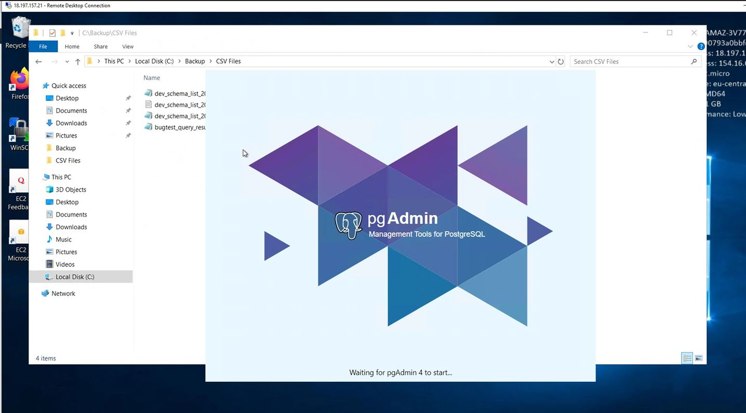

**Step2. Run that SQL script in Dev schema.**

select 'set search_path to '''||pg_namespace.nspname||'''; XXXX'  
from pg_namespace, pg_user  
where pg_user.usesysid = pg_namespace.nspowner  
and pg_user.usename in ('nonstopgov', 'postgres')  
and pg_namespace.nspname not like 'pg_temp%'  
and pg_namespace.nspname not like 'pg_toast%'  
and pg_namespace.nspname not in ('public', 'jdbc', 'pg_catalog', 'information_schema');

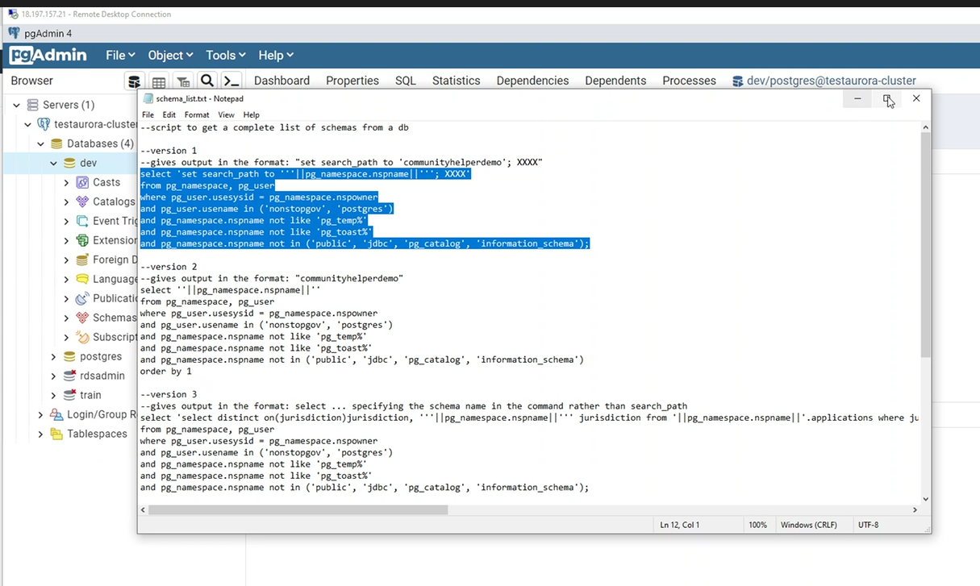

Step 3. Run that SQL script.

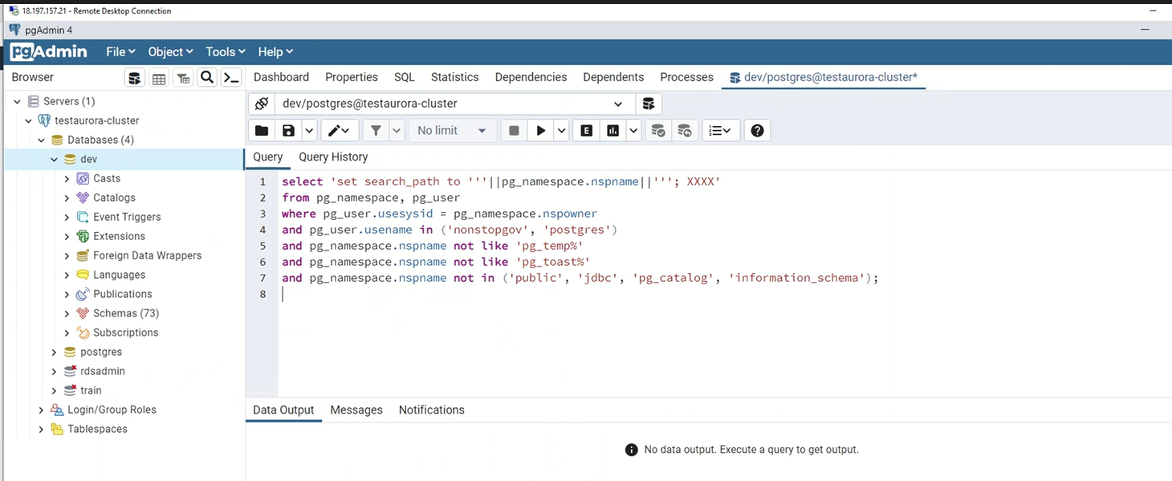

**Step 4. Save result to file as below option.**

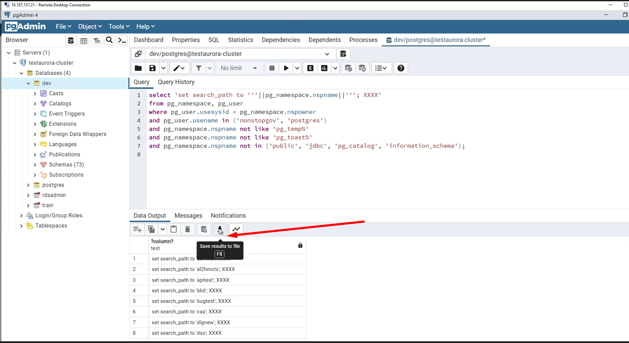

**Step 5. Open that file text in notepad and replace “”.**

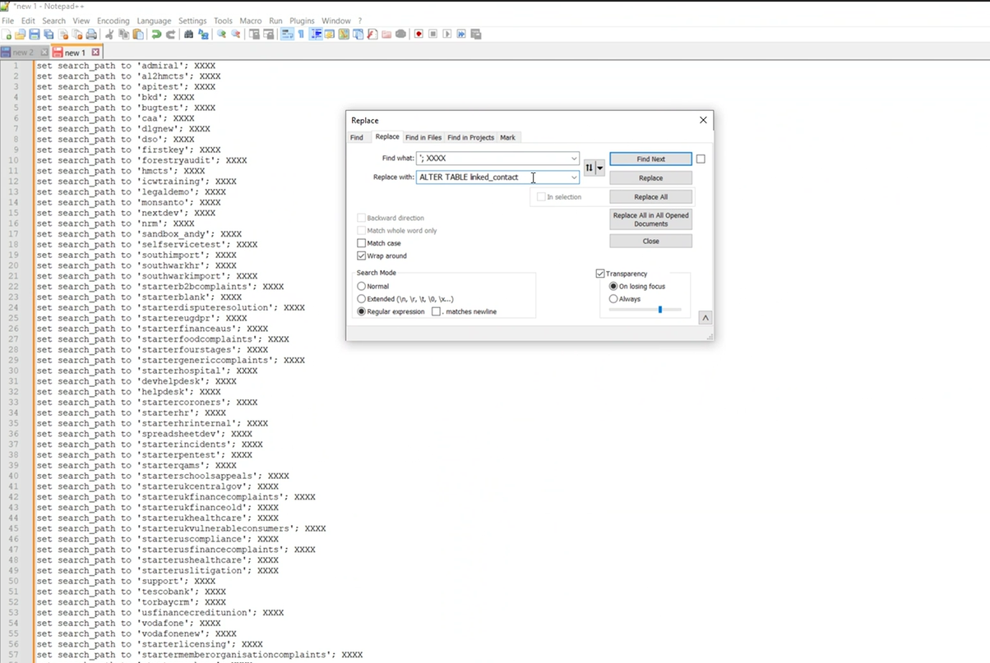

**Step 6. Now replace; XXXX with suggested SQL text.**

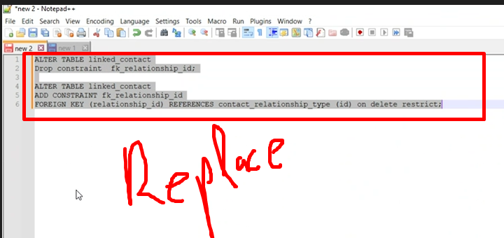

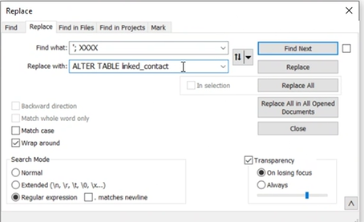

**Step 7. Copy the SQL script and run in Dev Schema as below.**

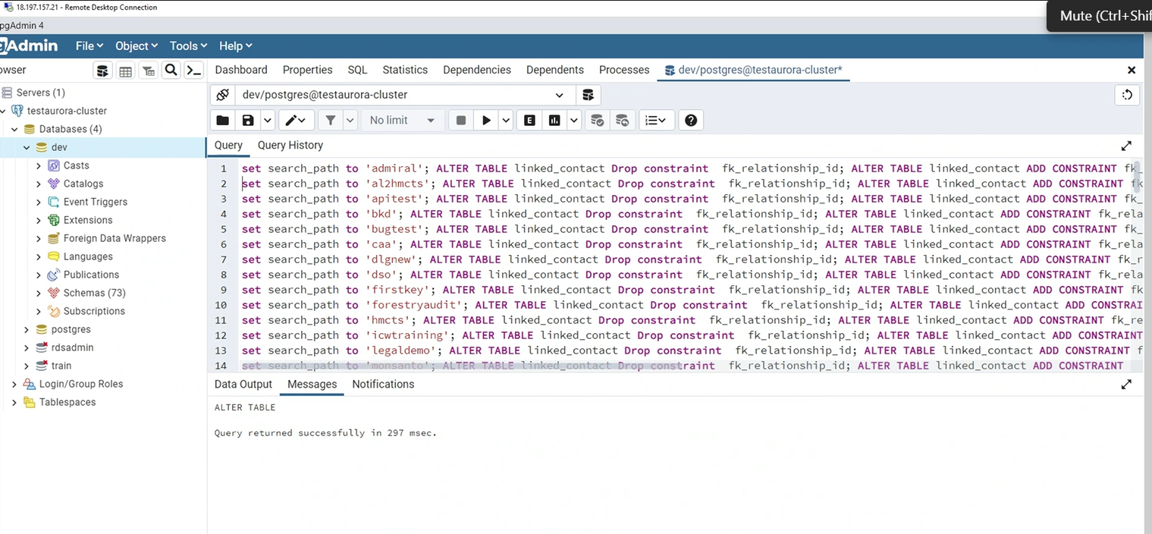

**Step 8. Now copy first two lines of SQL script and paste it in UAT server Pg-admin schema query.**

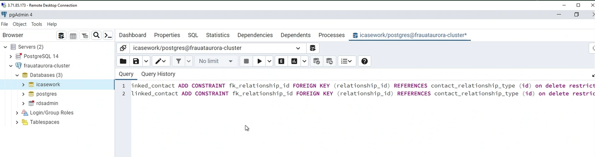

**Step 9. Now check with worksheet and change/edit schema name with suggested schemas.**

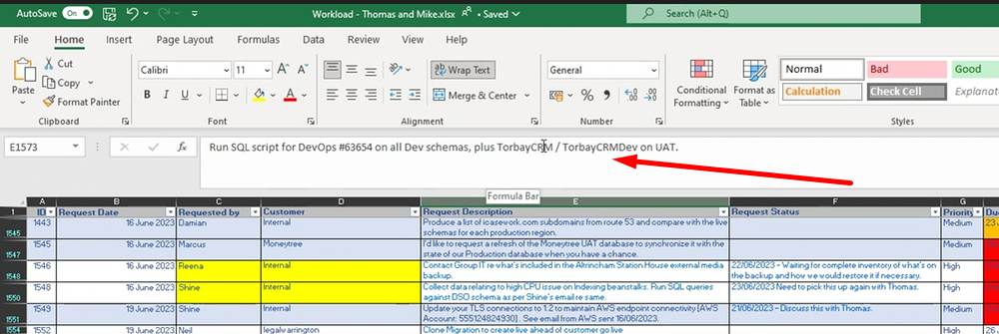

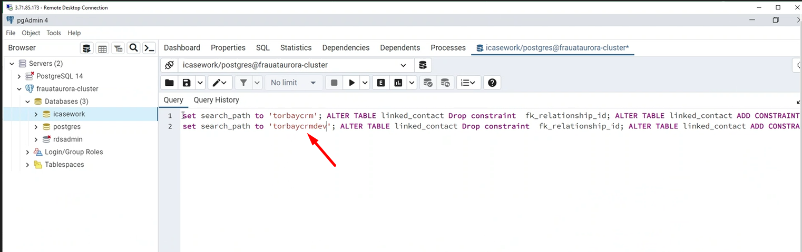

**Run that query**

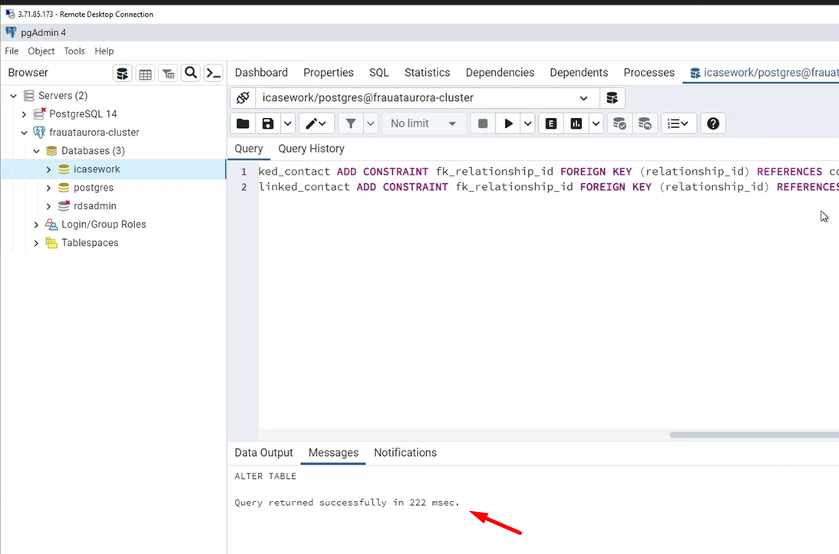

**It’s done now.**